First English Lutheran Church
Butler, Pennsylvania

Service of Holy Communion
Fourth Sunday of Easter
May 11, 2025
10:00 a.m.

GATHERING

PRELUDE

Easter Greeting
Alleluia, Christ is Risen!
He is risen indeed!

WELCOME

THANKSGIVING FOR BAPTISM

The congregation may stand.

Gathering HYMN
“Good Christian Friends, Rejoice and Sing” Red Book #385

GREETING
The grace of our Lord Jesus Christ, the love of God, and the communion of the Holy Spirit be with you all.
And also with you.

KYRIE page 120 in the front of the red book

THIS IS THE FEAST page 122 in the front of the red book

Prayer of the Day
Let us pray. O God of peace, you brought again from the dead our Lord Jesus Christ, the great shepherd of the sheep. By the blood of your eternal covenant, make us complete in everything good that we may do your will, and work among us all that is well-pleasing in your sight, through Jesus Christ, our Savior and Lord, who lives and reigns with you and the Holy Spirit, one God, now and forever.
Amen.

The congregation may sit.

THE WORD

CHILDREN’S SERMON

First ReadinG Acts 9:36-43

Dorcas was a faithful and devoted woman of charity in the community of Joppa. Her kindness and her work with clothing were well-known, especially to the widows in town. When she fell ill and died, Peter raised her back to life through the power of prayer.

³⁶ Now in Joppa there was a disciple whose name was Tabitha, which in Greek is Dorcas. She was devoted to good works and acts of charity. ³⁷ At that time she became ill and died. When they had washed her, they laid her in a room upstairs. ³⁸ Since Lydda was near Joppa, the disciples, who heard that Peter was there, sent two men to him with the request, “Please come to us without delay.” ³⁹ So Peter got up and went with them; and when he arrived, they took him to the room upstairs. All the widows stood beside him, weeping and showing tunics and other clothing that Dorcas had made while she was with them. ⁴⁰ Peter put all of them outside, and then he knelt down and prayed. He turned to the body and said, “Tabitha, get up.” Then she opened her eyes, and seeing Peter, she sat up. ⁴¹ He gave her his hand and helped her up. Then calling the saints and widows, he showed her to be alive. ⁴² This became known throughout Joppa, and many believed in the Lord. ⁴³ Meanwhile he stayed in Joppa for some time with a certain Simon, a tanner.

The word of the Lord.

Thanks be to God.

PSALM 23 read responsively

¹ The Lord is my shepherd;
I shall not be in want.
² The Lord makes me lie down in green pastures
and leads me beside still waters.
³ You restore my soul, O Lord,
and guide me along right pathways for your name’s sake.
⁴ Though I walk through the valley of the shadow of death, I shall fear no evil;
for you are with me; your rod and your staff, they comfort me.
⁵ You prepare a table before me in the presence of my enemies;
you anoint my head with oil, and my cup is running over.
⁶ Surely goodness and mercy shall follow me all the days of my life,
and I will dwell in the house of the Lord forever.

SECOND READING Revelation 7:9-17

Christ is the shepherd who leads his faithful to springs of the water of life. Christ is also the lamb who vanquishes sin and suffering.

⁹ After this I looked, and there was a great multitude that no one could count, from every nation, from all tribes and peoples and languages, standing before the throne and before the Lamb, robed in white, with palm branches in their hands. ¹⁰ They cried out in a loud voice, saying,
“Salvation belongs to our God who is seated on the throne, and to the Lamb!”
¹¹ And all the angels stood around the throne and around the elders and the four living creatures, and they fell on their faces before the throne and worshiped God, ¹² singing,
“Amen! Blessing and glory and wisdom
and thanksgiving and honor
and power and might
be to our God forever and ever! Amen.”
¹³ Then one of the elders addressed me, saying, “Who are these, robed in white, and where have they come from?” ¹⁴ I said to him, “Sir, you are the one that knows.” Then he said to me, “These are they who have come out of the great ordeal; they have washed their robes and made them white in the blood of the Lamb.
¹⁵ For this reason they are before the throne of God,
and worship him day and night within his temple,
and the one who is seated on the throne will shelter them.
¹⁶ They will hunger no more, and thirst no more;
the sun will not strike them,
nor any scorching heat;
¹⁷ for the Lamb at the center of the throne will be their shepherd,
and he will guide them to springs of the water of life,
and God will wipe away every tear from their eyes.”

The word of the Lord.

Thanks be to God.

The congregation may stand.

GOSPEL ACCLAMATION

Gospel John 10:22-30
The holy gospel of our Lord Jesus Christ according to John, the tenth chapter.
Glory to you, O Lord.

Jesus responds to questions about his identity with the remarkable claim that he and the Father are one. Those who understand this are his sheep; they hear his voice, follow, and will never be snatched from his hand.

²² At that time the festival of the Dedication took place in Jerusalem. It was winter, ²³ and Jesus was walking in the temple, in the portico of Solomon. ²⁴ So the Jews gathered around him and said to him, “How long will you keep us in suspense? If you are the Messiah, tell us plainly.” ²⁵ Jesus answered, “I have told you, and you do not believe. The works that I do in my Father’s name testify to me; ²⁶ but you do not believe, because you do not belong to my sheep. ²⁷ My sheep hear my voice. I know them, and they follow me. ²⁸ I give them eternal life, and they will never perish. No one will snatch them out of my hand. ²⁹ What my Father has given me is greater than all else, and no one can snatch it out of the Father’s hand. ³⁰ The Father and I are one.”

The Gospel of the Lord.
Praise to you, O Christ.

The congregation may sit.
Sermon

The congregation may stand.
HYMN OF THE DAY
“The King of Love My Shepherd Is” Red Book #502

NICENE CREED
We believe in one God,
the Father, the Almighty,
maker of heaven and earth,
of all that is, seen and unseen.
We believe in one Lord, Jesus Christ,
the only Son of God,
eternally begotten of the Father,
God from God, Light from Light,
true God from true God,
begotten, not made,
of one Being with the Father;
through him all things were made.
For us and for our salvation
he came down from heaven,
was incarnate of the Holy Spirit and the virgin Mary
and became truly human.
For our sake he was crucified under Pontius Pilate;
he suffered death and was buried.
On the third day he rose again
in accordance with the scriptures;
he ascended into heaven
and is seated at the right hand of the Father.
He will come again in glory
to judge the living and the dead,
and his kingdom will have no end.
We believe in the Holy Spirit, the Lord, the giver of life,
who proceeds from the Father and the Son,
who with the Father and the Son is worshiped and glorified,
who has spoken through the prophets.
We believe in one holy catholic and apostolic church.
We acknowledge one baptism for the forgiveness of sins.
We look for the resurrection of the dead,
and the life of the world to come. Amen.

PRAYERS OF INTERCESSION
God of resurrection and new life, we come before you in prayer for the church, the world, and all who are in need.

A brief silence.
The congregation may kneel or adopt another appropriate posture for prayer.

After each petition, the assisting minister bids:
God of grace,
The congregation responds:
Hear our prayer.
The presiding minister concludes:
We commend these and all our prayers to you, O God, trusting that you are always with us; in the name of Jesus Christ, our risen Savior.
Amen.

The congregation may stand.

THE MEAL

Peace
The peace of Christ be with you always.
And also with you.

After sharing the peace, the congregation may sit.

ORGAN OFFERTORY

The ushers present the offerings and gifts of bread and wine for communion.

CHOIR ANTHEM
“My Shepherd’s Mighty Aid” - Dimitri Bortniansky
Ivan Sokolov, arr.

The congregation may stand.

OFFERING PRAYER led by the assisting minister

Great Thanksgiving

It is indeed right, our duty and our joy….we praise your name and join their unending hymn:

All holy God, how wonderful is the work of your hands!...(the prayers continue)
Therefore let us proclaim the mystery of faith:
Christ has died. Christ is risen. Christ will come again.

God of love, we commemorate the love of Jesus whom death could not bind, but who rose from the grave, and sits exalted in glory on the throne of creation…(the prayers continue)
Then, at last, will all creation be one and all divisions healed;
And we shall sing your praise, united forever in the name of Jesus Christ through whom, with whom, in whom, in the unity of the Holy Spirit, all glory and honor is yours, almighty God, for ever and ever.
Amen
Lord’s Prayer
Gathered into one by the Holy Spirit, let us pray as Jesus taught us:
Our Father, who art in heaven,
hallowed be thy name,
thy kingdom come,
thy will be done on earth as it is in heaven.
Give us this day our daily bread;
and forgive us our trespasses,
as we forgive those who trespass against us;
and lead us not into temptation,
but deliver us from evil.
For thine is the kingdom,
and the power, and the glory,
forever and ever. Amen.

Invitation to Communion
The gifts of God given for the people of God. Come to this banquet of resurrection and new life.

LAMB OF GOD
The congregation may sit.

SHARING OF THE SACRAMENT
All are welcome to Holy Communion today. Lutherans believe that Christ is truly present in the bread and wine. The ushers will invite you forward to receive. Gluten free wafers are available; please let the pastor know if you wish to receive them. If you are able to receive either bread or wine (but not both), please know that you still receive the full communion.

HYMN DURING COMMUNION
“You Lord are Both Lamb and Shepherd” Purple Book #954

After all have received, the congregation may stand.

BLESSING AFTER COMMUNION
The body and blood of our Lord Jesus Christ strengthen you and keep you in his grace.
Amen.

SONG AFTER COMMUNION
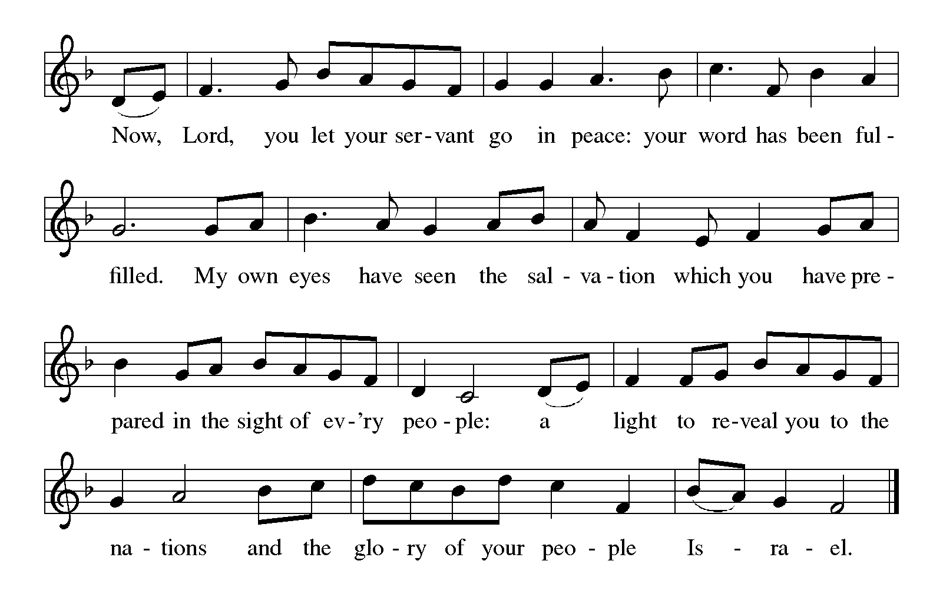

Prayer after Communion led by the assisting minister

THE SENDING

BLESSING OF BABY BLANKETS AND SENDING OF JESSICA KAMERER IN MISSION

Blessing
May God who has brought us from death to life fill us with great joy. Almighty God, Father, ☩ Son, and Holy Spirit, bless you now and forever. Amen.
SENDING HYMN
“Christ the Lord is Risen Today” Red Book #373

Dismissal
Go in peace. Serve the Lord!
Thanks be to God.

POSTLUDE

SERVING IN WORSHIP TODAY
The Rev. Kimberly van Driel | Presiding Minister
Linda Mathias | Assisting Minister
Sue Morrow | Communion Assistant
Jeanne Graff | Reader
Christiaan van Driel | Crucifer
Alex Kamerer | Acolyte
Bryan Helsel | Organist
Harry Cunningham | Choir Director
Sue Morrow | AV Assisting Minister
Gracie Love | PowerPoint Minister
Bill and Judy Vilcheck; Jake Stevens | Ushers
Susan Farrell and Sue Morrow | Counters
Roxanne Glagola | Altar Guild

Altar flowers are given to the glory of God by Sue and Jack Lehew,
in loving memory of Tamm.

All are welcome to join us for coffee hour social hall after worship today.

THIS WEEK AT FIRST ENGLISH
Mon., 5/12 | 5:00 PM | Community Dinner
 | 8:00 PM | NA Meeting (Social Hall)
Tues., 5/13 | 7:00 PM | Council Meeting
Wed., 5/14 | 8:00 AM | Health Clinic Meeting (Social Hall)
Thurs., 5/15 | 10:30 AM | Bible Study
 | 7:00 PM | Choir Rehearsal
 | 7:30 PM | NA Meeting (Downstairs)
Sat., 5/17 | 12:00 PM | NA Meeting (Downstairs)
Sun., 5/18 | 9:00 AM | Bible Study (Social Hall)
 | 10:00 AM | Worship
 | 5:30 PM | AA Meeting (Downstairs)

ANNOUNCEMENTS
If you would like to add someone to the prayer list, please add them to the list on the bulletin board in the social hall or contact the church office officefelc@zoominternet.net

We welcome Bryan Helsel as organist today. Thank you, Bryan, for sharing your gifts with us!

Today we bless baby blankets and commission Jessica Kamerer for an upcoming mission trip to Uganda. Jessie is traveling with Mama Tulia Ministries, a Christian organization that supports premature babies and their mothers in every dimension of life. Jessie will be leaving Pittsburgh on May 19 and returning on May 30. Along the way, she will also visit with other ministries that support vulnerable women and youth who have survived violence, abuse, or who are living with poverty or illness, including HIV/AIDS. Along the way, she will be giving blankets made by FELC’s prayer shawl ministry as gifts to newly baptized women and children. She treasures your prayers for her trip and for Mama Tulia’s ministries.

Next Sunday, May 18, intergenerational events return! Our theme is living in God’s grace.

Submissions for the June newsletter are due to Heather in the church office by Tuesday, May 20.

PRAYERS
Family of John Beatty; Janie Wetzel; Joan Giese; DJ Sampson; Nicole Waltrip; Justine Brown; Darrell Mueller; Bruce Solomon & family; Keith Graff; Signe Mitchell; Cindy Regis; Marsh Miller; Hannah Love; Gerry and John O’Rourke; Karen Boltz’s sister & her family; Shirley Mould; Nelson Ng; Valerie Kurth; Sue Henry

NEXT WEEK’S READINGS
Acts 11:1-18
Peter’s vision: God give the Gentiles repentance that leads to life
Psalm 148
The splendor of the Lord is over earth and heaven. (Ps. 148:13)
Revelation 21:1-6
New heaven, new earth: springs of living water in the new Jerusalem
John 13:31-35
Jesus gives a new commandment: Love one another as I have loved you

Liturgical portions of today’s service are reprinted with permission under Augsburg Fortress Liturgies Annual License #SAS028762.

One License Licensing Permission: Reprinted/Podcast/Streamed with permission under One License #A-734698. All Rights Reserved.

