First English Lutheran Church
Butler, Pennsylvania

Service of Holy Communion
Fifth Sunday of Easter
May 18, 2025
10:00 a.m.

GATHERING

PRELUDE
“Voluntary” - Charles Vincent
“Christ Is Arisen” - J.K.F. Fischer
“Jesus Christ Is Risen Today” - Healey Willian

Easter Greeting
Alleluia, Christ is Risen!
He is risen indeed!

WELCOME
The congregation may stand.

THANKSGIVING FOR BAPTISM

Gathering HYMN
“Love Divine, All Loves Excelling” Red Book #631

GREETING
The grace of our Lord Jesus Christ, the love of God, and the communion of the Holy Spirit be with you all.
And also with you.

KYRIE page 120 in the front of the red book

THIS IS THE FEAST page 122 in the front of the red book

Prayer of the Day
Let us pray. O Lord God, you teach us that without love, our actions gain nothing. Pour into our hearts your most excellent gift of love, that, made alive by your Spirit, we may know goodness and peace, through your Son, Jesus Christ, our Savior and Lord, who lives and reigns with you and the Holy Spirit, one God, now and forever.
Amen.

The congregation may sit.

THE WORD

CHILDREN’S SERMON

fiRST READING Acts 11:1-18

In defense of his earlier baptism of non-Jewish believers, Peter demonstrates to the members of the Jerusalem church that God’s intention to love Gentiles as well as Jews is revealed in Jesus’ testimony. In this way the mission to the Gentiles is officially authorized.

¹ Now the apostles and the believers who were in Judea heard that the Gentiles had also accepted the word of God. ² So when Peter went up to Jerusalem, the circumcised believers criticized him, ³ saying, “Why did you go to uncircumcised men and eat with them?” ⁴ Then Peter began to explain it to them, step by step, saying, ⁵ “I was in the city of Joppa praying, and in a trance I saw a vision. There was something like a large sheet coming down from heaven, being lowered by its four corners; and it came close to me. ⁶ As I looked at it closely I saw four-footed animals, beasts of prey, reptiles, and birds of the air. ⁷ I also heard a voice saying to me, ‘Get up, Peter; kill and eat.’ ⁸ But I replied, ‘By no means, Lord; for nothing profane or unclean has ever entered my mouth.’ ⁹ But a second time the voice answered from heaven, ‘What God has made clean, you must not call profane.’ ¹⁰ This happened three times; then everything was pulled up again to heaven. ¹¹ At that very moment three men, sent to me from Caesarea, arrived at the house where we were. ¹² The Spirit told me to go with them and not to make a distinction between them and us. These six brothers also accompanied me, and we entered the man’s house. ¹³ He told us how he had seen the angel standing in his house and saying, ‘Send to Joppa and bring Simon, who is called Peter; ¹⁴ he will give you a message by which you and your entire household will be saved.’ ¹⁵ And as I began to speak, the Holy Spirit fell upon them just as it had upon us at the beginning. ¹⁶ And I remembered the word of the Lord, how he had said, ‘John baptized with water, but you will be baptized with the Holy Spirit.’ ¹⁷ If then God gave them the same gift that he gave us when we believed in the Lord Jesus Christ, who was I that I could hinder God?” ¹⁸ When they heard this, they were silenced. And they praised God, saying, “Then God has given even to the Gentiles the repentance that leads to life.

The word of the Lord.

Thanks be to God.

PSALM 148 read responsively

¹ Hallelujah! Praise the Lord | from the heavens;
praise God | in the heights.
² Praise the Lord, | all you angels;
sing praise, all you | hosts of heaven.
³ Praise the Lord, | sun and moon;
sing praise, all you | shining stars.
⁴ Praise the Lord, heav- | en of heavens,
and you waters a- | bove the heavens.
⁵ Let them praise the name | of the Lord,
who commanded, and they | were created,
⁶ who made them stand fast forev- | er and ever,
giving them a law that shall not | pass away.
⁷ Praise the Lord | from the earth,
you sea monsters | and all deeps;
⁸ fire and hail, | snow and fog,
tempestuous wind, do- | ing God’s will;
⁹ mountains | and all hills,
fruit trees | and all cedars;
¹⁰ wild beasts | and all cattle,
creeping things and | flying birds;
¹¹ sovereigns of the earth | and all peoples,
princes and all rulers | of the world;
¹² young | men and maidens,
old and | young together.
¹³ Let them praise the name | of the Lord,
whose name only is exalted, whose splendor is over | earth and heaven.
¹⁴ The Lord has raised up strength for the people and praise for all | faithful servants,
the children of Israel, a people who are near the Lord. | Hallelujah!

SECOND READING Revelation 21:1-6

John’s vision shows us that in the resurrection the new age has dawned; God dwells with us already. Yet we wait for the time when the tears that cloud our vision will be wiped away. Then we will see the new heaven, new earth, and new Jerusalem.

¹ I saw a new heaven and a new earth; for the first heaven and the first earth had passed away, and the sea was no more. ² And I saw the holy city, the new Jerusalem, coming down out of heaven from God, prepared as a bride adorned for her husband. ³ And I heard a loud voice from the throne saying,
“See, the home of God is among mortals.
He will dwell with them;
they will be his peoples,
and God himself will be with them;
⁴ he will wipe every tear from their eyes.
Death will be no more;
mourning and crying and pain will be no more,
for the first things have passed away.”
⁵ And the one who was seated on the throne said, “See, I am making all things new.” Also he said, “Write this, for these words are trustworthy and true.” ⁶ Then he said to me, “It is done! I am the Alpha and the Omega, the beginning and the end. To the thirsty I will give water as a gift from the spring of the water of life.”

The word of the Lord.

Thanks be to God.

The congregation may stand.

GOSPEL ACCLAMATION

Gospel John 13:31-35
After washing the disciples’ feet, predicting his betrayal, and then revealing his betrayer, Jesus speaks of his glorification on the cross. This deep complicated love of Jesus, even to death on the cross, will be the distinctive mark of Jesus’ community.

The holy gospel of our Lord Jesus Christ according to John, the thirteenth chapter.
Glory to you, O Lord.

When he had gone out, Jesus said, “Now the Son of Man has been glorified, and God has been glorified in him. ³² If God has been glorified in him, God will also glorify him in himself and will glorify him at once. ³³ Little children, I am with you only a little longer. You will look for me; and as I said to the Jews so now I say to you, ‘Where I am going, you cannot come.’ ³⁴ I give you a new commandment, that you love one another. Just as I have loved you, you also should love one another. ³⁵ By this everyone will know that you are my disciples, if you have love for one another.”

The Gospel of the Lord.
Praise to you, O Christ.

The congregation may sit.
Sermon

The congregation may stand.
HYMN OF THE DAY
“Where Charity and Love Prevail” Red Book #359

NICENE CREED
We believe in one God,
the Father, the Almighty,
maker of heaven and earth,
of all that is, seen and unseen.
We believe in one Lord, Jesus Christ,
the only Son of God,
eternally begotten of the Father,
God from God, Light from Light,
true God from true God,
begotten, not made,
of one Being with the Father;
through him all things were made.
For us and for our salvation
he came down from heaven,
was incarnate of the Holy Spirit and the virgin Mary
and became truly human.
For our sake he was crucified under Pontius Pilate;
he suffered death and was buried.
On the third day he rose again
in accordance with the scriptures;
he ascended into heaven
and is seated at the right hand of the Father.
He will come again in glory
to judge the living and the dead,
and his kingdom will have no end.
We believe in the Holy Spirit, the Lord, the giver of life,
who proceeds from the Father and the Son,
who with the Father and the Son is worshiped and glorified,
who has spoken through the prophets.
We believe in one holy catholic and apostolic church.
We acknowledge one baptism for the forgiveness of sins.
We look for the resurrection of the dead,
and the life of the world to come. Amen.

PRAYERS OF INTERCESSION
Gracious God, on the night before his death, your Son gave us a new commandment, that we should love one another as he loved us. Make your church a witness to your redeeming love for all people without exclusion, especially those most overlooked in our community. Hear us, O God:
Your mercy is great.

Surround with your mercy those people at risk of starvation in the midst of conflict and war, especially in Sudan, the Democratic Republic of Congo, and Gaza, and inspire those with means to send food, money, medicine, and help. Hear us, O God:
Your mercy is great

Guard those who serve in this nation’s armed forces, that they may be protected from harm and danger and that they may do their work with integrity and honor. Hear us, O God:
Your mercy is great.

Strengthen those who work for justice and peace, especially when they feel defeated by evil. Hear us, O God:
Your mercy is great.

Wipe away the tears of all who are lonely, grieving, or sad and comfort them in their sorrow. Hear us, O God:
Your mercy is great.

Help us look to your promise of a new creation as we make our way through this beautiful but broken world. We commend to your care all those who have died this week…Raise us with them and with your Son to greater glory. Hear us, O God:
Your mercy is great.

A brief silence.

After each petition, the assisting minister bids:
God of grace,
The congregation responds:
Hear our prayer.
The presiding minister concludes:
We commend these and all our prayers to you, O God, trusting that you are always with us; in the name of Jesus Christ, our risen Savior.
Amen.

The congregation may stand.

THE MEAL

Peace
The peace of Christ be with you always.
And also with you.

After sharing the peace, the congregation may sit.

ORGAN OFFERTORY
“Abide, O Dearest Jesus” - James Coe

The ushers present the offerings and gifts of bread and wine for communion.

CHOIR ANTHEM
“Touch that Soothes and Heals” -Gregg DeMey, b. 1972
(from All Creation Sings, #939)

The congregation may stand.

OFFERING PRAYER led by the assisting minister

Great Thanksgiving

It is indeed right, our duty and our joy….we praise your name and join their unending hymn:

All holy God, how wonderful is the work of your hands!...(the prayers continue)
Therefore let us proclaim the mystery of faith:
Christ has died. Christ is risen. Christ will come again.
God of love, we commemorate the love of Jesus whom death could not bind, but who rose from the grave, and sits exalted in glory on the throne of creation…(the prayers continue)
Then, at last, will all creation be one and all divisions healed;
And we shall sing your praise, united forever in the name of Jesus Christ through whom, with whom, in whom, in the unity of the Holy Spirit, all glory and honor is yours, almighty God, for ever and ever.
Amen
Lord’s Prayer
Gathered into one by the Holy Spirit, let us pray as Jesus taught us:
Our Father, who art in heaven,
hallowed be thy name,
thy kingdom come,
thy will be done on earth as it is in heaven.
Give us this day our daily bread;
and forgive us our trespasses,
as we forgive those who trespass against us;
and lead us not into temptation,
but deliver us from evil.
For thine is the kingdom,
and the power, and the glory,
forever and ever. Amen.

Invitation to Communion
The gifts of God given for the people of God. Come to this banquet of resurrection and new life.

LAMB OF GOD

The congregation may sit.

SHARING OF THE SACRAMENT
All are welcome to Holy Communion today. Lutherans believe that Christ is truly present in the bread and wine. The ushers will invite you forward to receive. Gluten free wafers are available; please let the pastor know if you wish to receive them. If you are able to receive either bread or wine (but not both), please know that you still receive the full communion.
After all have received, the congregation may stand.

HYMN DURING COMMUNION
“Beloved, God's Chosen” Red Book #648

BLESSING AFTER COMMUNION
The body and blood of our Lord Jesus Christ strengthen you and keep you in his grace.
Amen.

SONG AFTER COMMUNION 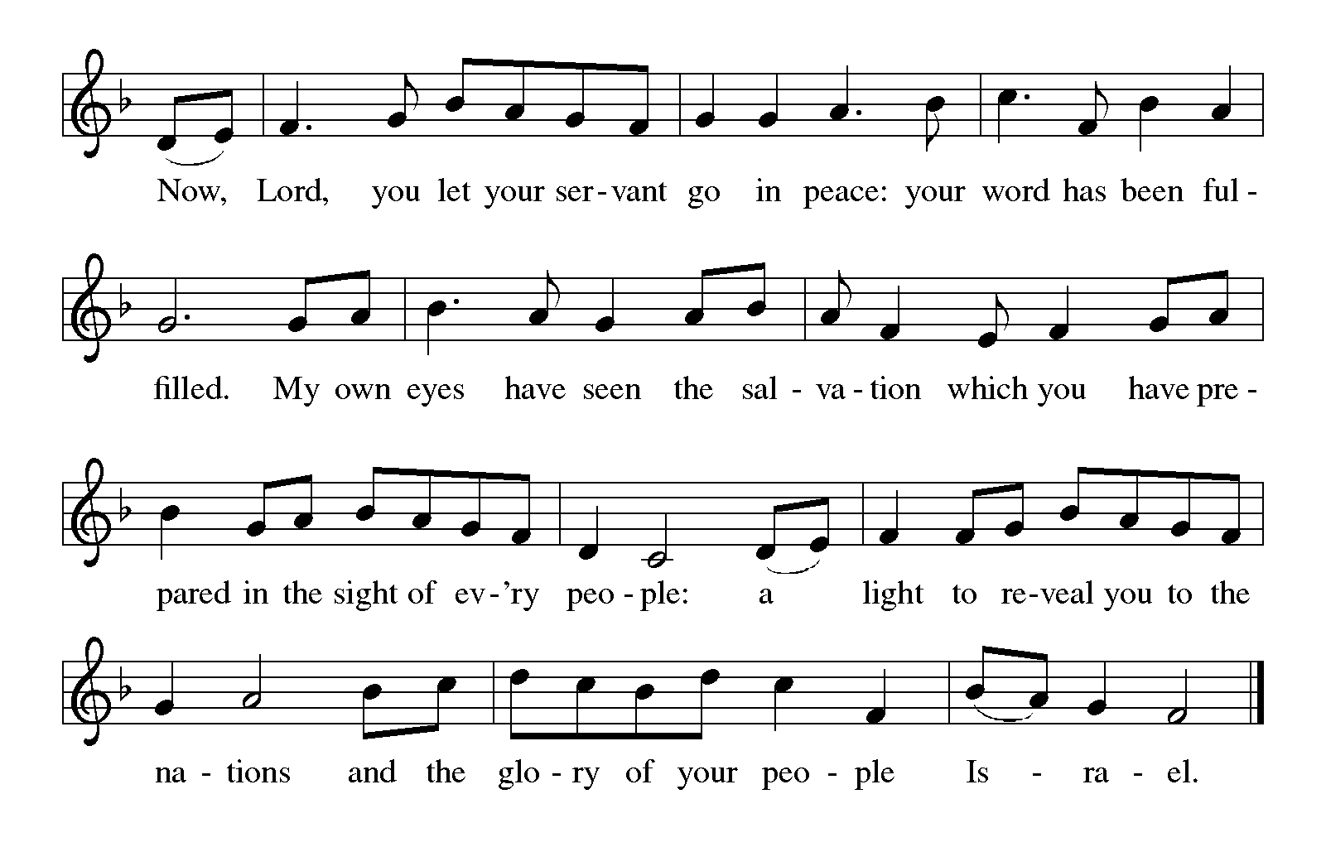

Prayer after Communion led by the assisting minister

THE SENDING
Blessing
May God who has brought us from death to life fill us with great joy. Almighty God, Father, ☩ Son, and Holy Spirit, bless you now and forever. Amen.
SENDING HYMN
“Thine is the Glory” Red Book #376

Dismissal
Go in peace. Serve the Lord!
Thanks be to God.

POSTLUDE
“Christ Is Risen! Shout Hosanna!” -William P. Rowan

SERVING IN WORSHIP TODAY
The Rev. Kimberly van Driel | Presiding Minister
Sandra Lefebvre | Assisting Minister
Jim Cunningham | Communion Assistant
Marlin Boltz | Reader
Sandy Lefebvre | Crucifer
TBA | Acolyte
Kevin Mathis | Organist
Harry Cunningham | Choir Director
Marlin Boltz | AV Assisting Minister
Karen Boltz | PowerPoint Minister
Susan Farrell Christiaan van Driel | Ushers
Jack and Amy Beiler | Counters
Roxanne Glagola | Altar Guild

Altar flowers are given to the glory of God by Sandra Lefebvre for loved ones.

Organ Flowers are given to the glory of God by Sharon Heist Miller for Glen’s birthday.

All are welcome to join us for coffee hour social hall after worship today.

THIS WEEK AT FIRST ENGLISH
Mon., 5/19 | 5:00 PM | Community Dinner
 | 8:00 PM | NA Meeting (Social Hall)
Tues., 5/20 | 6:00 AM | Primary Election
Thurs., 5/22 | 10:30 AM | Bible Study
 | 7:00 PM | Choir Rehearsal
 | 7:30 PM | NA Meeting (Downstairs)
Sat., 5/24 | 12:00 PM | NA Meeting (Downstairs)
Sun., 5/25 | 9:00 AM | Bible Study (Social Hall)
 | 10:00 AM | Worship
 | 5:30 PM | AA Meeting (Downstairs)

ANNOUNCEMENTS

Please join us following worship for strawberry shortcake and reflecting on what it means to live by God’s grace. This will be our final intergenerational event for the program year.
Due to our building serving as a polling place for primary elections, the church office will operate remotely on Tuesday, May 20th. Please call the church office number or email officefelc@zoominternet.net.

If you would like to add someone to the prayer list, please add them to the list on the bulletin board in the social hall or contact the church office officefelc@zoominternet.net.

Submission for the May newsletter are due to Heather in the church office by Tuesday, May 20.

PRAYERS
Family of John Beatty; Janie Wetzel; Joan Giese; DJ Sampson; Nicole Waltrip; Justine Brown; Darrell Mueller; Bruce Solomon & family; Keith Graff; Signe Mitchell; Cindy Regis; Marsh Miller; Hannah Love; Gerry and John O’Rourke; Karen Boltz’s sister & her family; Shirley Mould; Nelson Ng; Valerie Kurth; Sue Henry; Tad Sellers; Aryl Bashline, Keeler Family

NEXT WEEK’S READINGS
Acts 16:9-15
Lydia and her household are baptized by Paul
Psalm 67
Let the nations be glad and sing for joy. (Ps. 67:4)
Revelation 21:10, 22—22:5
The Lamb is the light of the city of God
John 14:23-29
The Father will send the Holy Spirit
John 5:1-9 (alternate)
Jesus heals on the Sabbath

Liturgical portions of today’s service are reprinted with permission under Augsburg Fortress Liturgies Annual License #SAS028762.

One License Licensing Permission: Reprinted/Podcast/Streamed with permission under One License #A-734698. All Rights Reserved.

